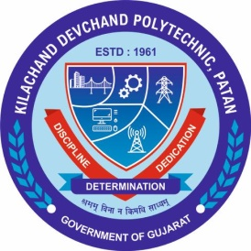
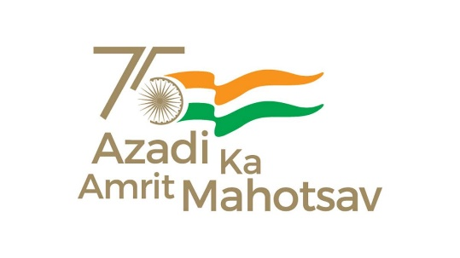

Student start-up research and innovation festival

“SSIP 2.0 Students Sensitization”

Program Report
Mechanical Department
K. D. Polytechnic, Patan

- DETAILS OF PROGRAM
Title of Program: | “SSIP 2.0 Sensitization”
Date: | 04/01/2022
Time: | 2:00 to 3:00
Venue: | H.E LAB Mechanical Department  K. D. Polytechnic, Patan.
Speaker: | Mr. Hiren Patel Coordinator Mechanical Department
Participant: | 1st Sem Mechanical Department Students. Total : 41

- Glimpse of program
